**Task [C]: READ ME**

**Set up Environment**

**Step 1 # Download and Install R**[Download Link <https://cran.r-project.org/bin/windows/base/> ]

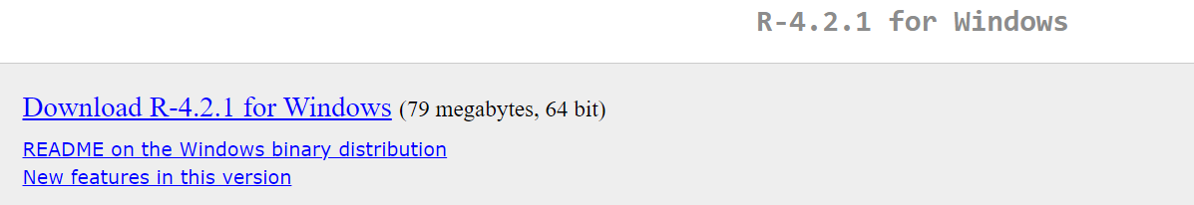

**Step 2 # Download and Install R Studio [For Windows download the second one]**[Download Link <https://www.rstudio.com/products/rstudio/download/#download> ]

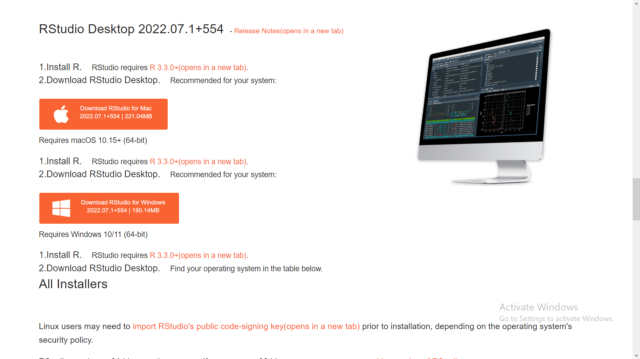

**Step 3 # Install useful packages with console command {one by one}**

**install.packages(plyr)**

**install.packages(readr)**

**install.packages(**rjson**)**

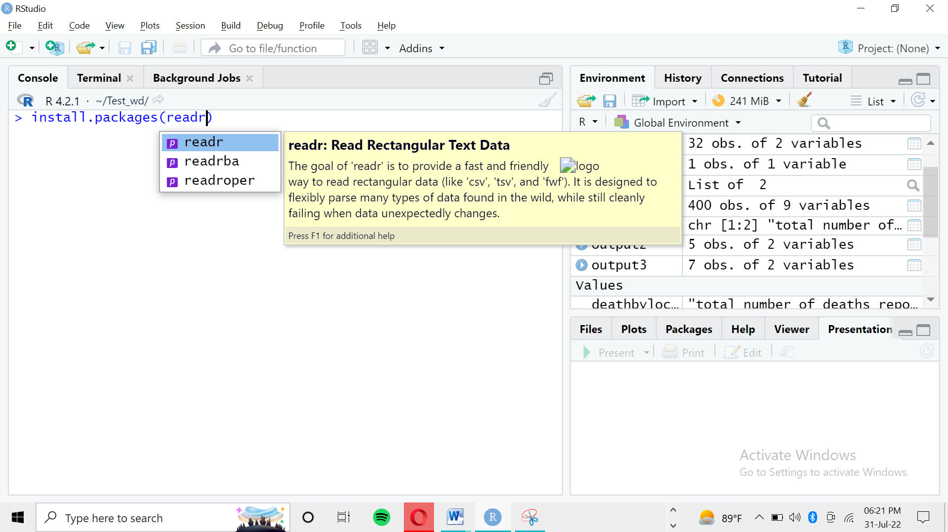

**Instructions for program execution**

**Step 4 # Open File named as Task [A] + Task [B]**

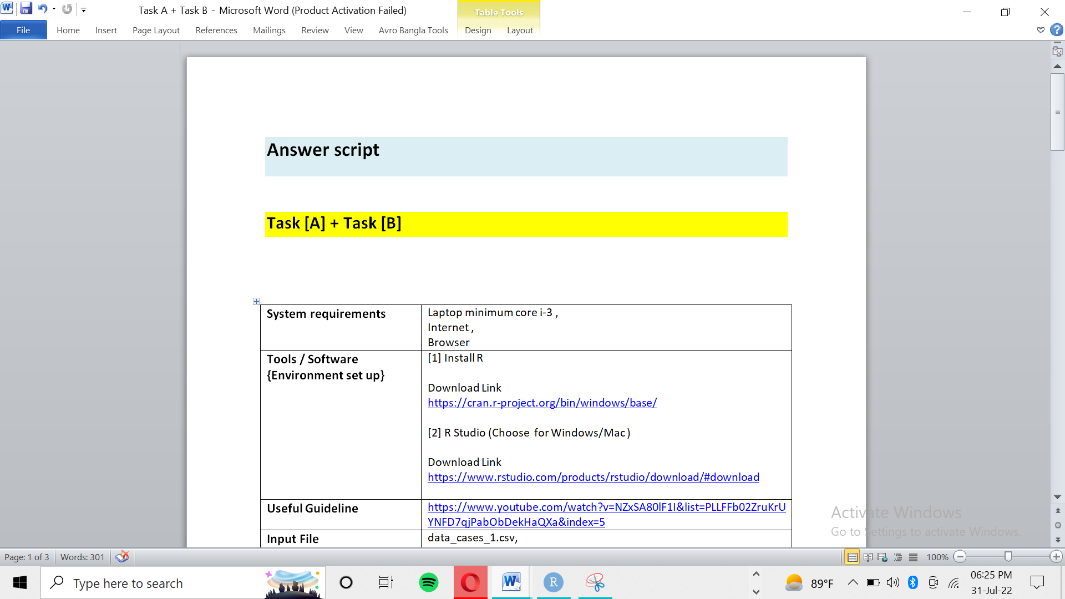

**Step 5 # Copy single line code and paste in console to execute the program. Please, don’t copy and paste whole the program in this page and be aware not to copy white spaces with the code line.**

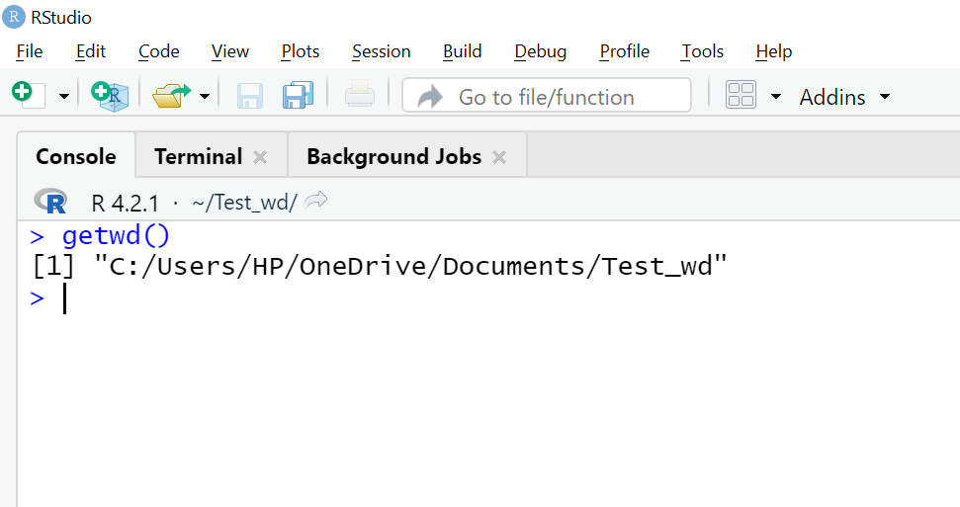

**Step 6 #** Set working directory in a folder named as Test_wd. Or Create a folder named as Test_wd. Here is the directory of mine. Please don’t copy this. You can follow this to keep your directory correct.

Then write your directory like the following and execute program to set directory successfully.

setwd(“C:/Users/HP/OneDrive/Documents/Test_wd”)

**Step 7 #** To be confirmed your last set working directory run the following code.

getwd()

**Note:** If this is successfully showing your directory then you are ready to run the code line by line to get the output for the given problem set.

**Step 8 #** Please keep your all file in the directory folder you have created as named Test_wd Or as other name you wished.

**Step 9 #** Please follow the file Task [A] + Task [B] and follow the program from step 3 to end to find the way to get desired output. All the best ☺

**Step 10 #** For the Task [D] + Task [E] Or new program you don’t need to repeat all the steps but follow the files ahead.

**Note:**

1. Text starting with # is a comment to understand the code below it.
2. Importing and exporting file is also mentioned by comment.
3. Only copy single line command and execute as per given instruction.
4. Aaa
5. Bbb